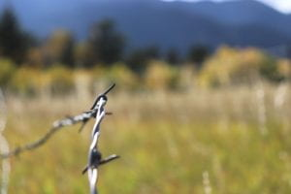
Jose
I love this picture and how the barbwire is the focus, but you can also see the mountains too.
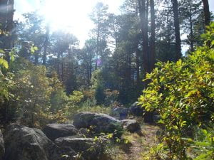
Eli
I like this picture and how it is looking up.
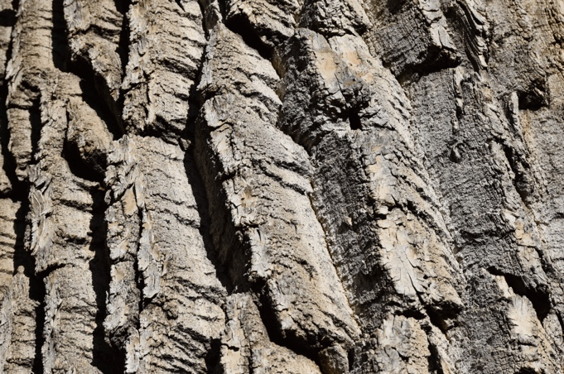
Hannah
I like how The bark looks up close.
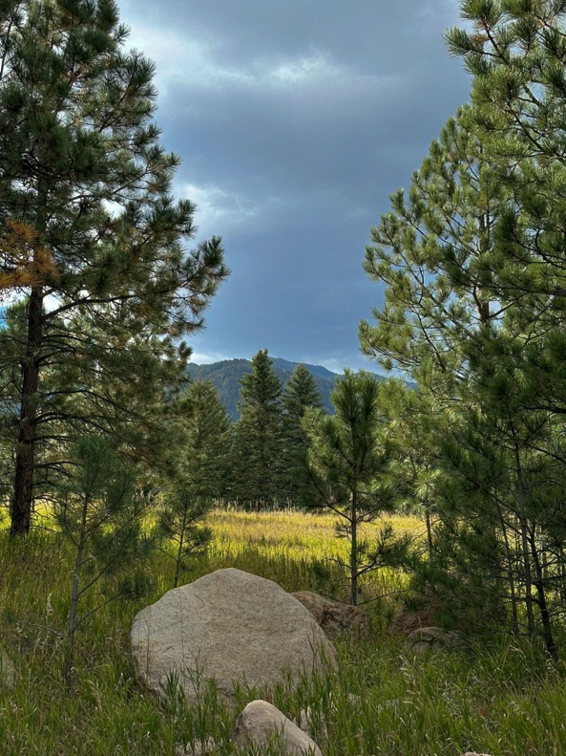
Marnie
I like how the trees make a clearing and how the rock is in the middle of the picture.

