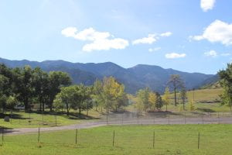
Jose
I like this picture a lot. I like how the quality is good and so is the lighting.
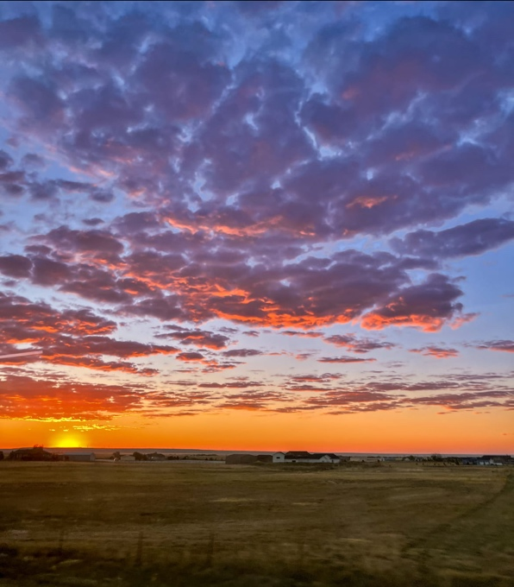
Hannah
I'm commenting on the sunset picture. I like this picture because I love sunsets and overall is a good picture.
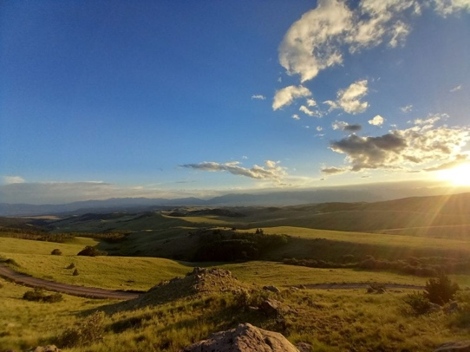
Oliver
I like the perspective of this picture. Also, how you can see the all the grassy hills.
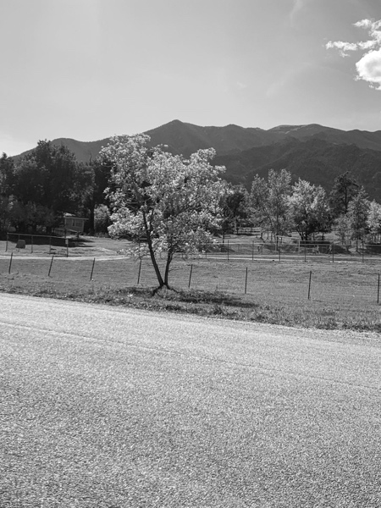
Adiena
I like how this picture captures the whole mountain. Also, how the picture is in black and white.

